Portfolio – Oviya Arunachalam
(Kindy let me know if there is any doubt through the process, I’ll see how to add things)
About
Hello! I’m Oviya Arunachalam, an aspiring Data, Operations, and Business Analyst. I enjoy working with data to uncover patterns and deliver actionable insights; after all, numbers speak louder than words. With a blend of technical skills and an operations mindset, I’m passionate about turning data into strategies that drive efficiency and impact.
Education
BE Robotics and Automation Engineering – PSG College of Technology, Coimbatore, India (graduated in July 2024)
MS Industrial and Operations Engineering – University of Michigan, Ann Arbor (expected to graduate in December 2025)
Skills
- Programming Languages: SQL, Python, R, familiar with HTML
- Libraries & Packages: Pandas, NumPy, scikit-learn, Matplotlib, Seaborn, TensorFlow, PyTorch
- Tools & Platforms: Jupyter, Visual Studio, PyCharm, Google Colab, phpMyAdmin, Excel, Anaconda, familiar with Tableau
- Data Management & Engineering: Advanced Joins, Aggregate Functions, Data Extraction, ETL, Data Automation
- Statistical Analysis: Regression Analysis, Hypothesis Testing, KPI Measurement
- Analytics & Visualization: Data Analysis, Data Visualization, Dashboard Building
Certifications
- Introduction to Data Science in Python
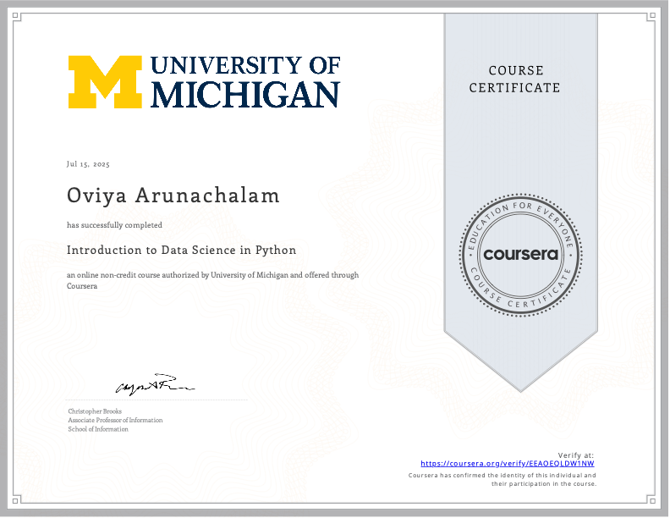
- Applied Plotting, Charting & Data Representation in Python
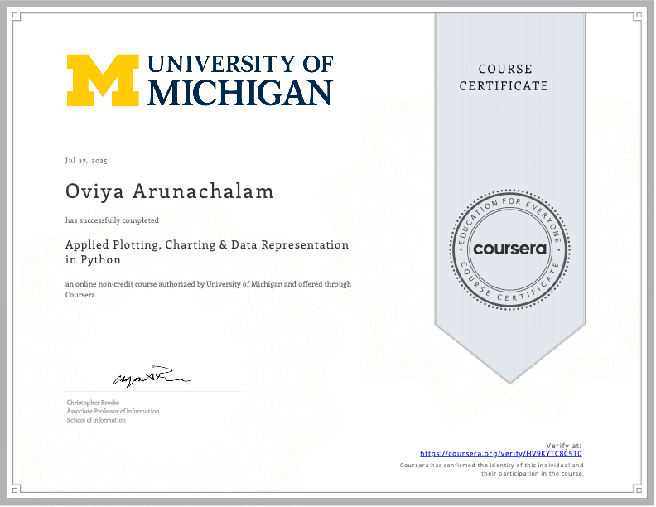
- Applied Machine Learning in Python
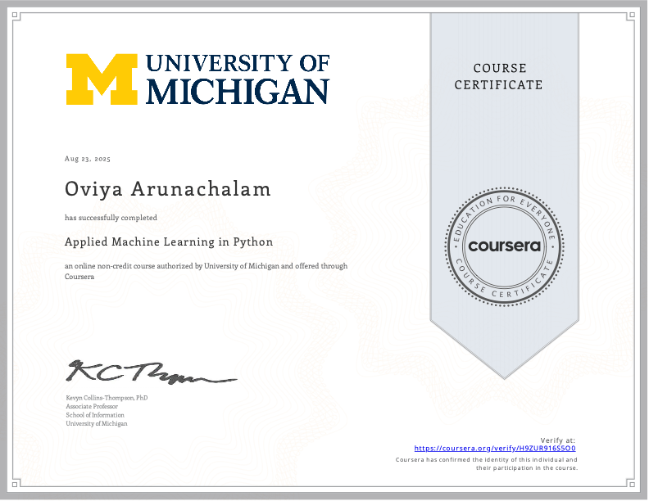
- Introduction to Structured Query Language
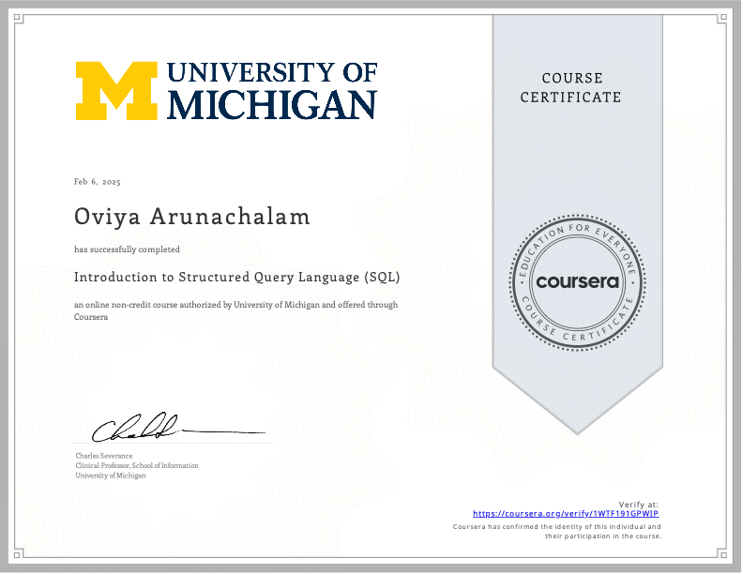
Experience
- Programmer Analyst – Rackham Graduate School, Institutional Research
  - Worked on database management and process automation projects, focusing on syncing and cleaning academic records across multiple MySQL databases.
  - Developed SQL triggers, stored procedures, and automated pipelines to enable seamless data updates and integrity checks.
  - Implemented data automation solutions that minimized manual work, improved accuracy, and streamlined student record management processes.
- Logistics Planning Intern – Hatsun Agro Products
  - Trained on SAP-LE to execute logistics processes, including bill of order generation and goods delivery planning.
  - Optimized routing and scheduling for distribution, ensuring efficient resource utilization and on-time delivery.
  - Gained hands-on experience in ERP-driven logistics and supply chain operations within a large-scale FMCG environment.
Projects (Please highlight the numerical values of the data)
- Cart Flow Optimization – Ford VanDyke Powertrain Center
Optimized material handling efficiency by analyzing cart flow across the shop floor. Applied discrete-event simulation, value-stream mapping, time-studies and Pareto analysis to identify bottlenecks and redesign cart routes. Delivered a 15% reduction in non-value-added time and improved throughput, supporting lean manufacturing initiatives in EV powertrain production.
- Business Model Development (NYC LL97 Compliance) - ThermoVerse
Developed a scalable market strategy for an energy optimization platform helping NYC buildings comply with LL97 emission regulations. Designed borough-specific pricing, segmentation, and financing strategies (PACE integration) to maximize adoption. Conducted financial modeling that projected a net profit of $2.40/sq.ft./year, outperforming traditional compliance models and creating a hybrid business plan with strong ROI potential.
- Optimizing Telemarketing Strategies: Customer Conversion Prediction for Insurance Sales
Built a predictive analytics model to identify key drivers of customer response in telemarketing campaigns using 56k+ records. Applied data cleaning, feature engineering, and class imbalance handling (SMOTEEN) to improve model reliability. Delivered a model that increased conversion prediction accuracy by 18%, enabling more targeted outreach and improved customer acquisition efficiency.
- Predictive Maintenance in Manufacturing using IIoT Integration
Built an IIoT-driven monitoring pipeline by developing machine learning algorithms for CNC machinery with real-time anomaly detection. Designed a live dashboard that flagged equipment health issues and, when fault indicators crossed a defined threshold, automatically emailed the shop-floor manager to schedule maintenance, reducing reactive fixes and supporting planned interventions.

- Stock Prediction using AI
Developed an LSTM-based deep learning model to forecast stock price trends using open-source Apple stock data. Implemented data preprocessing, feature engineering, and sequential modeling to capture temporal patterns. Achieved a forecasting accuracy improvement of 12% over baseline methods, supporting data-driven financial decision-making.
Publications (Add a link to access the PDF document of the article)
- Leveraging the benefits of digital twin in delivering personalized medicine using IOT
Published research exploring how digital twin technology, integrated with IoT, can enable real-time patient monitoring and tailored treatment plans. Highlighted the potential of virtual replicas to improve healthcare outcomes by simulating patient-specific scenarios for more precise and personalized medicine.
- Control and autonomy of microbots
Published research focused on the control mechanisms and autonomous navigation of microbots for precision applications. Explored algorithmic approaches to enhance mobility, decision-making, and adaptability, highlighting the potential of micro-scale robotics in advancing biomedical and engineering solutions.
Leadership & Service
- Secretary and Joint Secretary of the Financial Club (Finverse) at PSG College of Technology (2022-2024).
- Administration head of Animal Welfare Club at PSG College of Technology (2022-2023).
- Senior executive of social media and publicity domain of Women Development Cell at PSG College of Technology (2022-2023).
- Certified by the Panchayat for 60 hours of social service regarding women health and sanitation, and children education.
Contact
- Email: oviyaa@umich.edu
- Phone: +1 (734) 596-3478
- Linkedin: www.linkedin.com/in/aoviya

